


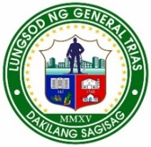
Republic of the Philippines
Province of Cavite
Region IV-A CALABARZON
City of General Trias

BARANGAY PANUNGYANAN

OFFICE OF THE PUNONG BARANGAY
B A R A N G A Y C L E A R A N C E

TO WHOM IT MAY CONCERN;

This is to certify that _______________________________of a legal age ( ) single ( ) married ( ) widower Filipino citizen , resident of this Barangay and presently residing at , PUROK ___ Barangay Panungyanan, General Trias City of Cavite.

Further, certify that he/she has no derogatory record filed in the office as of this date.
Furthermore, some indexes such as specimen signature and right thumb mark are belonged to him/her.
This certification is being issued upon his/her request for the following purposes.
( )Local Employment ( ) Postal ID Application
( ) Medica/Financial Assistance ( ) Bank Requirements
( ) Scholarship Program ( ) Water /Electric Connection
( ) Educational Assistance ( )Other’s

Issued ___ day of _______ 2025 at Barangay Hall of Panungyanan General Trias City,Cavite.

_______________________
Requesters Signature
CTC No : __________
Issued on:__________
General Trias City, Cavite RIGHT THUMBMARK
ATTESTED BY: APPROVED BY:

JEREMIAH-ANGELICA B. CAHINHINAN RENATO S. ALMANZOR Barangay Secretary Punong Barangay

Note: Valid for 6 months from date of issue.
Note: Not valid without official seal/erasure.

